**String Join Method**

In visual basic, the string Join method is useful to concatenate all the elements of string array using the specified separator between each element.

Visual Basic String Join Method Syntax

Public Shared Function Join(ByVal separator As String, ByVal ParamArray values As String()) As String

Visual Basic String Join Method Example

Dim sArr As String() = {"Welcome", "to", "VB.NET"}

Console.WriteLine("Join with Hypen: {0}", String.Join("-", sArr))

Dim sArr1 As String() = {"Krishna", "Kishore", "Kiran"}

Console.WriteLine("Join with Comma: {0}", String.Join(", ", sArr1))

Console.WriteLine("Press Enter Key to Exit..")

Console.ReadLine()

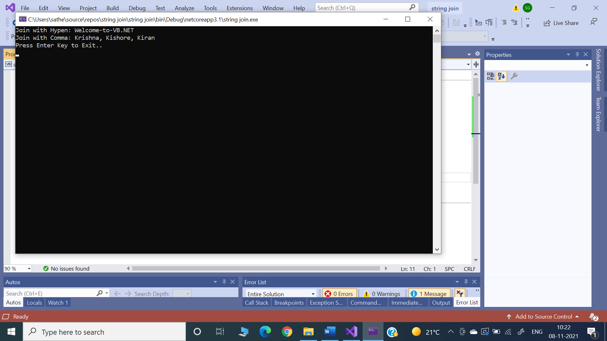

**InStr() Method**



This method returns the position of the first occurrence of one string within another string.

Syntax 1

InStr([start,] string1, string2)

Syntax 2

InStr(start, string1, string2[, compare])

Argument Description

Start An integer representing the position in string1 to begin the search, with the first character in the string as 1

string1 The string to search

string2 The string to find

compare 0 if a case-sensitive search is desired

1 if a case-insensitive search is desired



Returns The position of the first character of string2 in string1

InStr returns a zero under the following conditions:



start is greater than the length of string2.

string1 is a null string.

string2 is not found.

Example



